IBM Assignment

K.Pavithra

950819106052

Before simulation

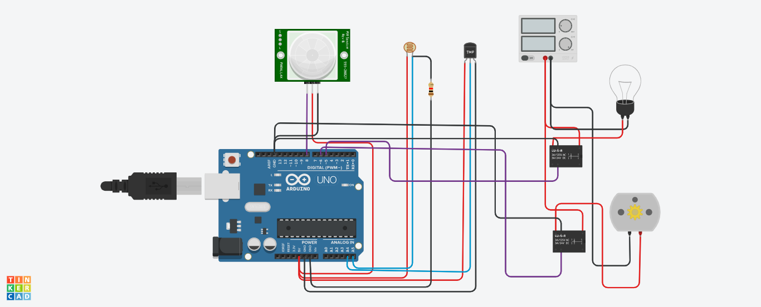

After simulation

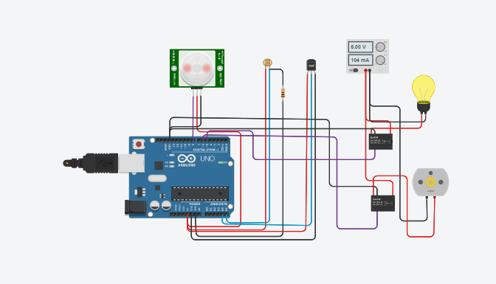

Code

float x,y,z,temp;

void setup( )

{

pinMode ( 8 , INPUT ) ;

pinMode ( 5 , OUTPUT ) ;

pinMode ( 6 , OUTPUT ) ;

pinMode ( A5, INPUT ) ;

pinMode ( A4 , INPUT ) ;

Serial.begin ( 9600 ) ;

}

void loop ( )

{

x = digitalRead ( 8 ) ;

y = analogRead ( A5 ) ;

z = analogRead ( A4 ) ;

Serial.println ( x ) ;

Serial.println ( y ) ;

Serial.println ( z ) ;

temp = ( double)z / 1024 ;

temp = temp\*5 ;

temp=temp - 0.5 ;

temp = temp\*100 ;

if ( ( x > 0 ) )

{

if ( ( y < 550 ) && ( temp > 30 ) )

{

digitalWrite ( 5 , HIGH ) ;

digitalWrite ( 6 , HIGH ) ;

}

else if ( ( y < 550 ) && ( temp < 30 ) )

{

digitalWrite ( 5 , HIGH ) ;

digitalWrite ( 6 , LOW ) ;

}

else if ( ( y > 550 ) && ( temp > 30 ) )

{

digitalWrite ( 5 , LOW ) ;

digitalWrite ( 6 , HIGH );

}

else if (( y > 550 ) && ( temp<30 ))

{

digitalWrite ( 5 , LOW ) ;

digitalWrite ( 6 , LOW ) ;

}

}

else

{

digitalWrite ( 5 , LOW ) ;

digitalWrite ( 6 , LOW ) ;

}

}

Tinkercad link

https://www.tinkercad.com/things/0K45DoW6oP7-magnificent-bombul-jarv/editel?sharecode=Im8GKV49tzF3S2gwa-uJ3F6cKh15bnJGC4Rq7Cl4TSA&sharecode=Im8GKV49tzF3S2gwa-uJ3F6cKh15bnJGC4Rq7Cl4TSA